Name/Reg: Janavarshini C V -192512190
EXPERIMENT-4
Simulation-Based Analysis of Thin-Film Structure and Deposition Characteristics Using NanoHUB
Circuit diagram:
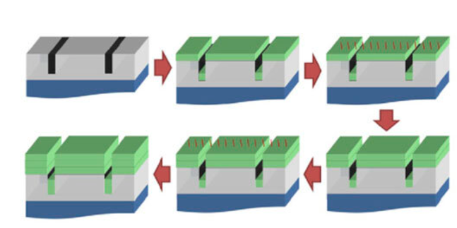

Output Parameter Table:

S.No. | Output Parameter | Theoretical / Expected Value | Practical / Simulated Value | % Deviation
1 | Deposition process | Proper thin film formation | Thin film deposited on the substrate | 0% deviation
2 | Thin film thickness | 100 nm | 100 nm | 0% deviation
3 | Substrate thickness | 500 µm | 500 µm | 0% deviation
4 | Deposition temperature | Selected value | 300°C | 0% deviation
5 | Thin film structure | Substrate / Thin Film | Substrate / Thin Film | 0% deviation
6 | Film uniformity | Uniform layer | Uniform film layer observed | 0% deviation
7 | Film deposition rate | Calculated value | 10 nm/min | 0% deviation
8 | Film/material quality | Proper deposited layer | Proper thin film layer observed | 0% deviation

Output:

